**LAB TASKS**

**TASK 01**

|  |  |
| --- | --- |
| **Function Call** | **Result** |
| SUBSTR(CONCAT(‘HIGH’, ‘SALARY’), 4, 6) | **HSA** |
| CONCAT(SUBSTR(‘INFORMATION’, 3, 4), ‘TECH’) | **FOTECH** |
| INSTR(CONCAT(‘GET’, ‘ING’), ‘TIN’) | **3** |
| ROUND(69.476, 1) | **69.5** |
| TRUNC(’13-MAR-90’, ‘MONTH’) | **01-MAR-90** |
| TRUNC(’13-MAR-90’, ‘YEAR’) | **01-JAN-90** |
| MOD(90, LENGTH(‘SEVENTY’)) | **6** |
| MONTHS_BETWEEN(’14-AUG-96’, ’23-MAR-95’) | **17** |

**Task 02 (i)**

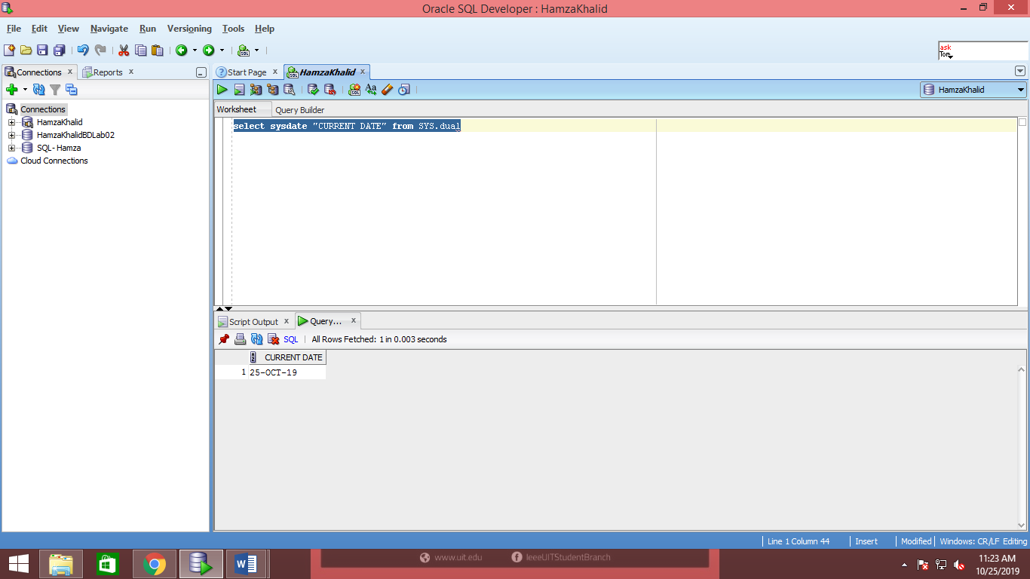

**Task 02 (ii)**

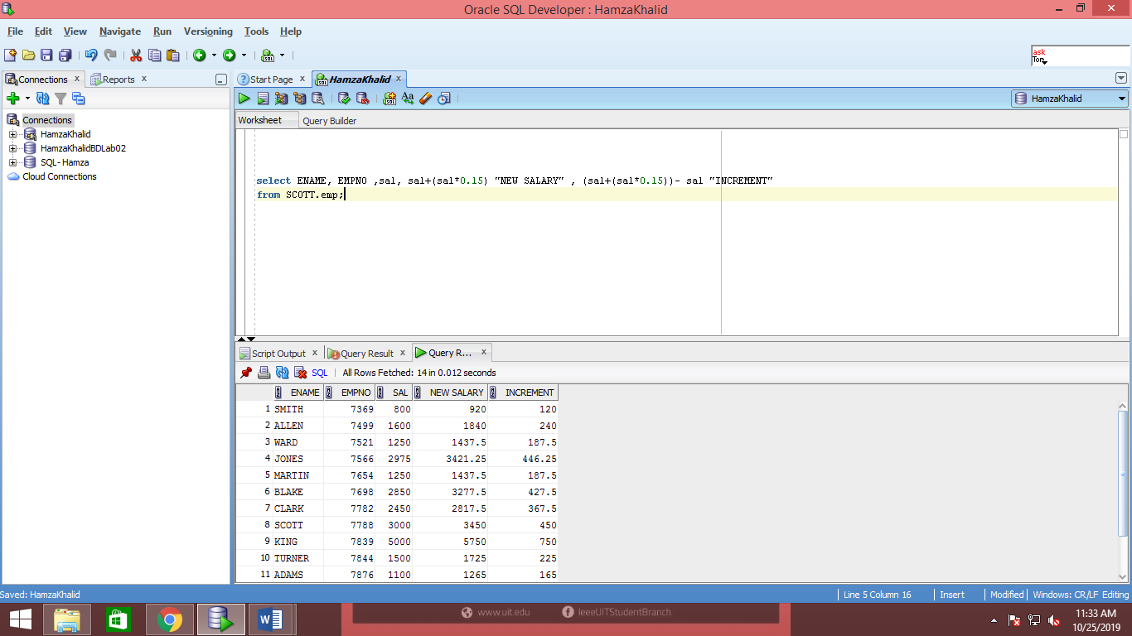

**Task 02 (iii)**

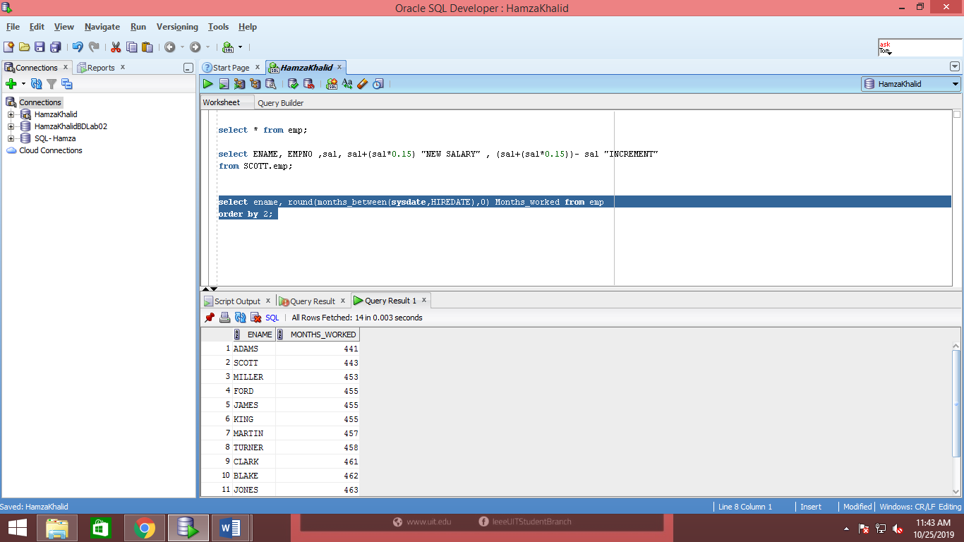

**Task 02 (iv)**

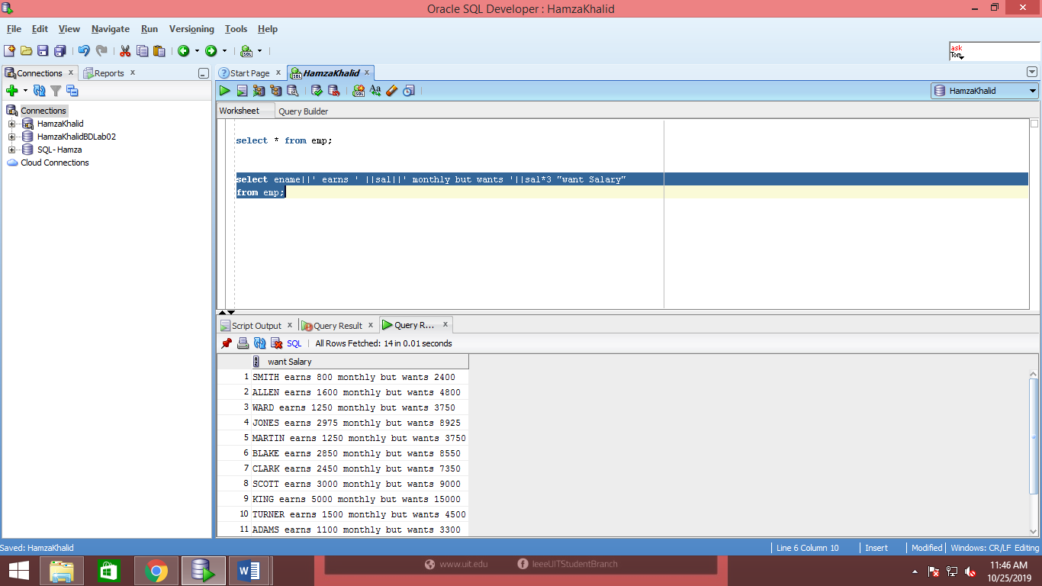

**Task 02 (v)**

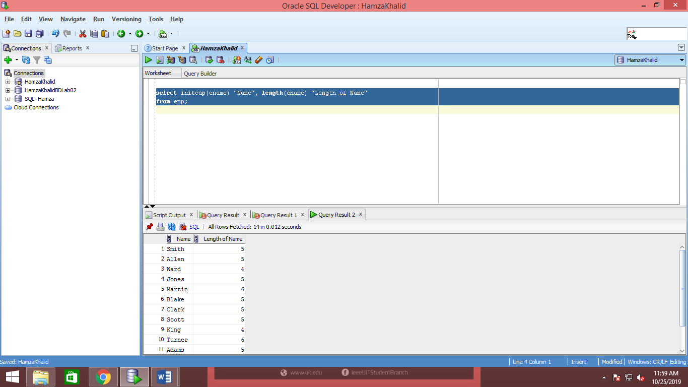

**Task 02 (vi)**

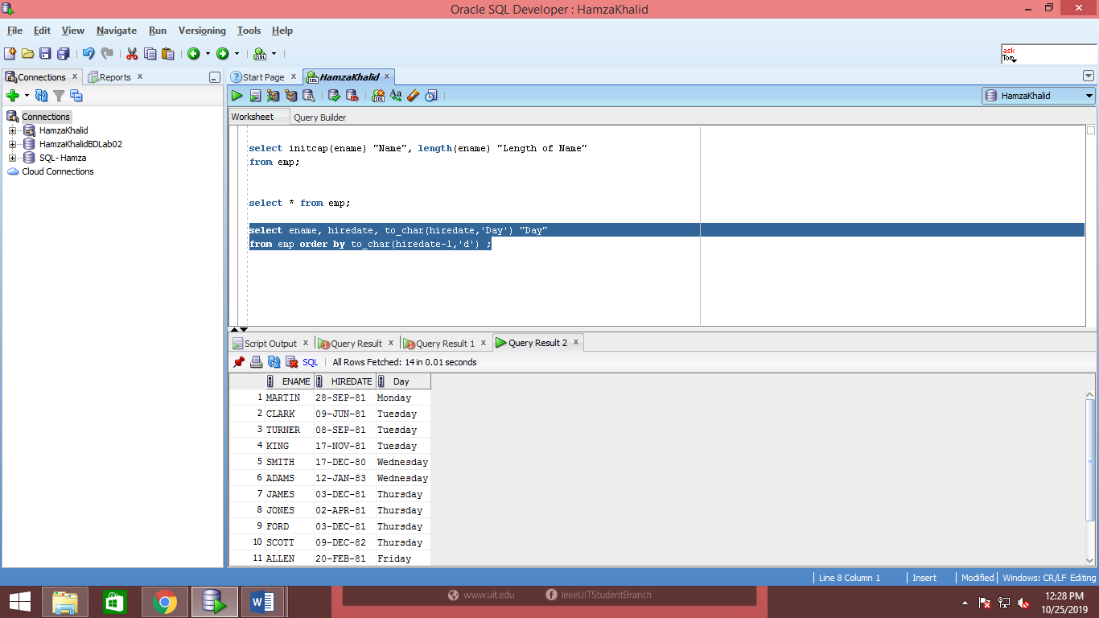

**Task 02 (vii)**

SELECT D. DEPTNO, D. DNAME, COUNT ('E. EMPNO') "NUMBER OF EMPLOYEES"FROM DEPT D, EMP EWHERE D. DEPTNO = E. DEPTNO GROUP BY D. DEPTNO, D. DNAME;

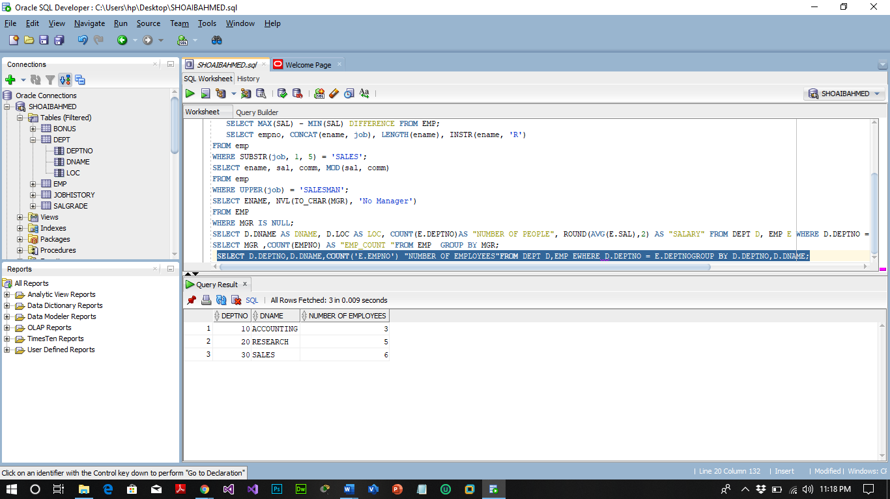

**Task 02 (viii)**

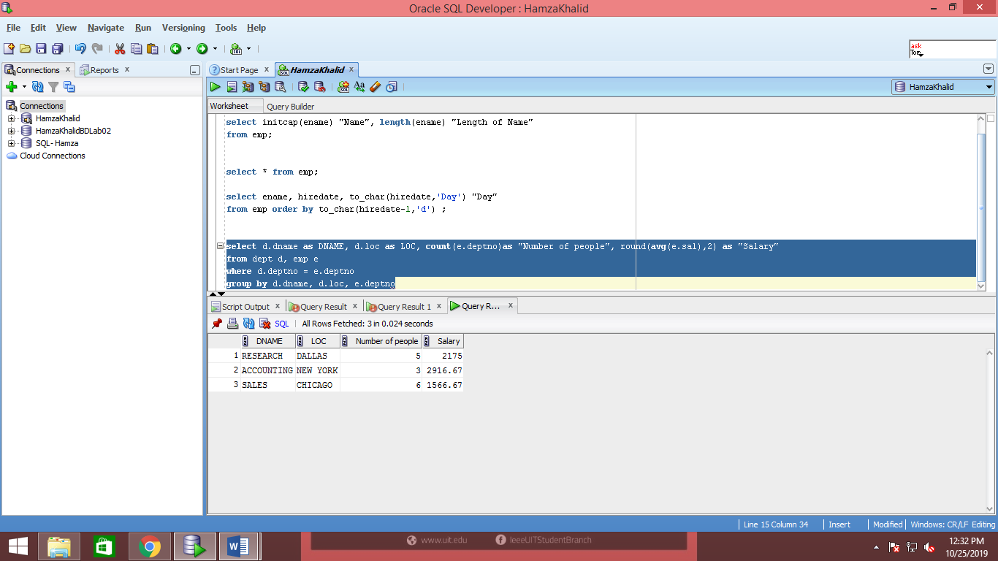

**Task 02 (ix)**

SELECT ENAME, DEPTNO, JOB FROM EMP WHERE DEPTNO= (SELECT DEPTNO FROM DEPT WHERE LOC = 'DALLAS');

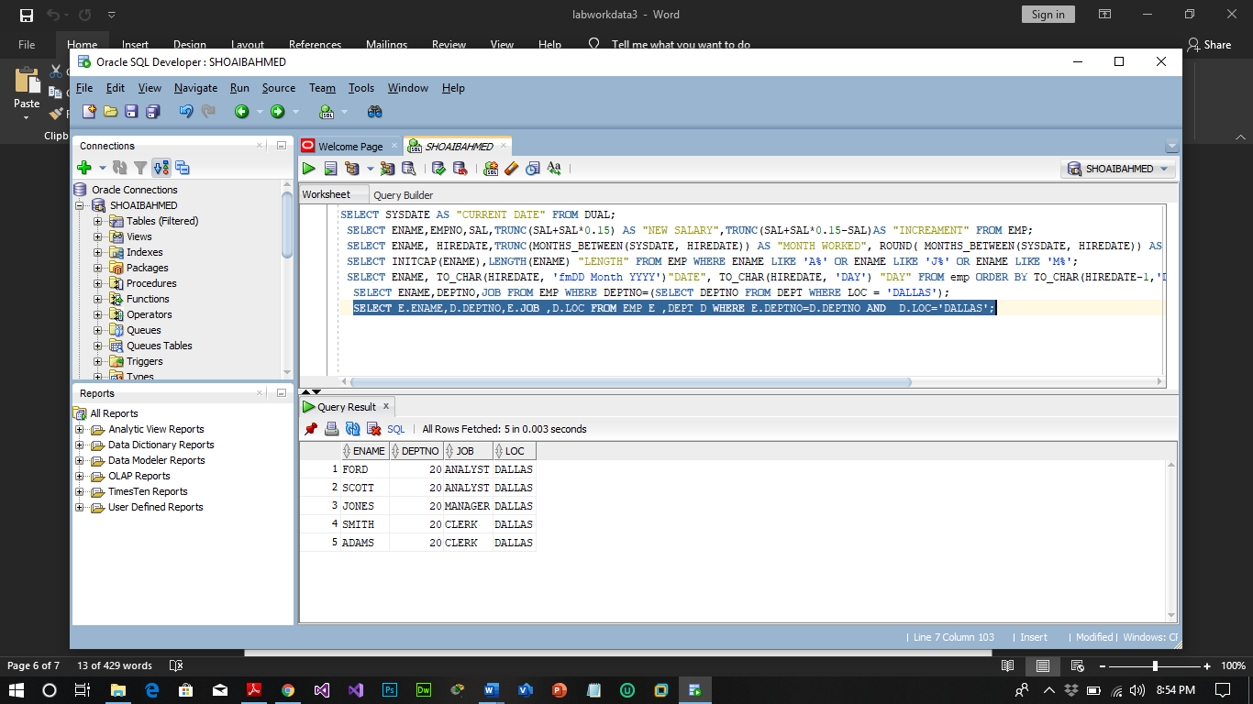

**Task 02 (x)**

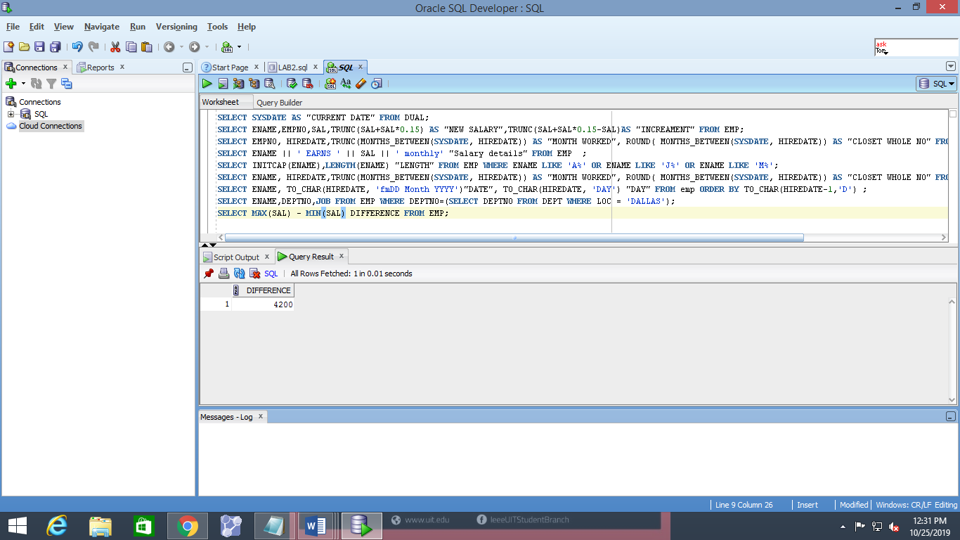

**Task 02 (xi)**

